# PWM to Analog V1.1 by Egon.Net

## Parts:

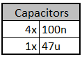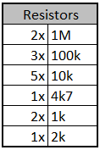

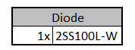

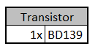



## Board configuration:

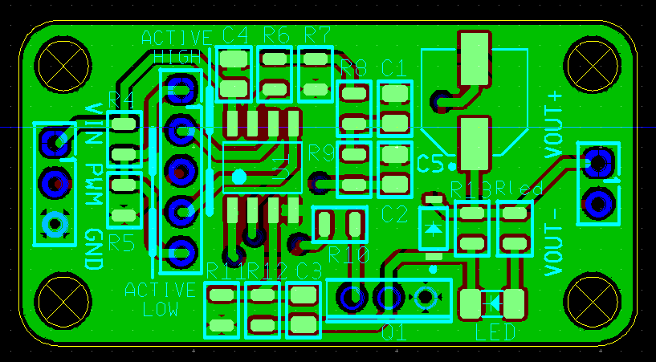Two jumpers should be used to configure PWM active high or low. The white marks on the board indicate the

jumper/short position: PWM ACTIVE LOW, marks on the left. PWM ACTIVE HIGH, marks on the right, so:

**PWM ACTIVE LOW**: pins 2-3 and 4-5 should be shorted, pin 1 unconnected.

**PWM ACTIVE HIGH**: pins 1-2 and 3-4 should be shorted, pin 5 unconnected.

(Pin 1 is topmost, marked with “1”, and down from there bottommost pin is pin 5.

## Led configuration:

The provided 0805 led has a 2k Rled for max led current (20mA) at 40V.

## Connections:

Vin: from 4.5V to 40V (although in test it worked as low as 3V)

PWM: from 0V to Vin (do not use a PWM voltage higher than Vin or lower than 0V). Duet open drain outputs can be used normally (PWM input is pulled high)

Vout: analog output (Vout- to Vout+) Vout+ = Vin, Vout- = Vin-analog_level

**WARNING: DO NOT CONNECT VOUT- TO GND!! ALWAYS MEASURE VOUT- AS A GND-REFERENCED VOLTAGE OR MEASURE DIFFERENTIAL FROM VOUT+ TO VOUT-**